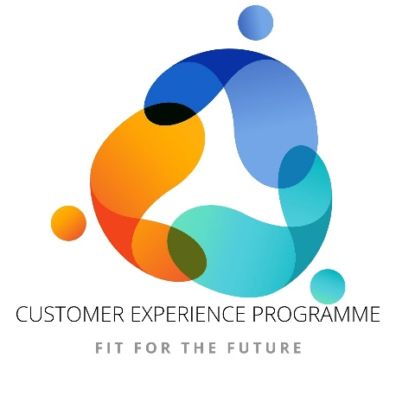

CITIZEN EXPERIENCE
STRATEGY 2023 – 2025
For everyone that lives in, works in or visits
the City of Oxford

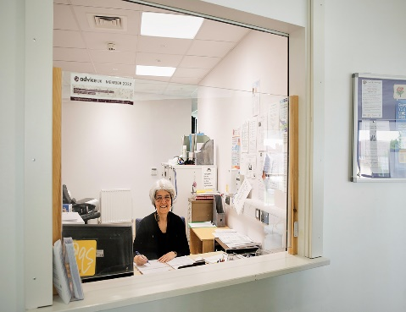

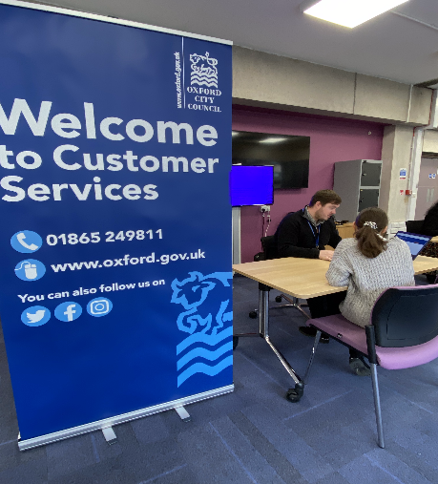
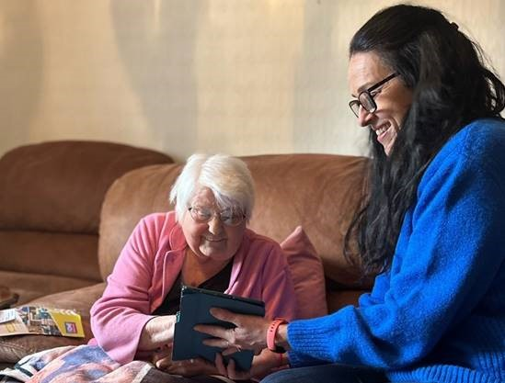

Foreword
Everyday hundreds of the city’s citizens engage with Oxford City Council, whether as individuals or as part of organisations and businesses. In addition, Oxford welcomes thousands of students and visitors a year who use our services. All those contacts help create Oxford City Council’s reputation and done well, encourage investment in the city as well as making it a great place to live, work and visit.
That is why Citizen Engagement matters, and why we need a robust and forward-looking strategy which will help shape the right priorities for our city. This strategy outlines a vision which is richer and more relevant than the narrower transactional nature of our current Customer Services strategy. It commits us to a more systematic engagement with all our citizens to ensure your feedback makes all we do of the highest possible quality.
We are facing a profound digital revolution with Councils like ours expected to meet higher standards than ever in terms of ease of use and access to services. For many citizens, interacting with the Council digitally and on the move is now the default expectation.
But we also must continue meet the needs of citizens who are digitally disadvantaged. There are stark differences in the city in terms of access to technology and broadband. We will continue to invest in telephony and face to face services so that no one is left behind, and in widening digital access.
We will continue to listen and work collaboratively with you to understand and make the changes we need to continually improve our services.
Change in an area like Citizen Engagement is a given; we must be at our best to meet and stay ahead of your changing demands.
And we will measure our performance, with clear targets which stretch to meet our collective ambition. We will celebrate our meeting them and explain and improve where we fall short, as we work hard to deliver this exciting vision.
Councillor Nigel Chapman
Cabinet member for Citizen Focused Services and Council Companies
Introduction
This Citizen Experience Strategy outlines the approach we will be taking to provide a positive experience for all of our citizens in accessing our services and engaging with us as a provider of them.
This Citizen Experience Strategy is more wide ranging than our previous customer contact strategies which were more transactional in nature and more focused on the first point of contact. This strategy will ensure that all of the City Council Services are in tune with the approach, and also embraces other organisations and community groups so that together, we provide the right support for anyone living, working or visiting Oxford.
Since our last Customer Contact Strategy which covered the period 2019 to 2022, the impact of digital technology in day-to-day life has grown significantly, and driven further improvements in the way we deliver services. Alongside this, our response to the Covid Pandemic has taught us much about the ways we can interact with our citizens, and quite rightly the expectation is to be able to engage in a range of ways including using more digital channels.

Current Context
It is important to understand the key demographics of the citizens the Council is serving, in order to ensure that any strategy we develop is relevant in addressing the city’s needs.
Oxford is a changing city that is becoming more diverse. According to the ONS Census 2021 data the population of Oxford is 162,040.
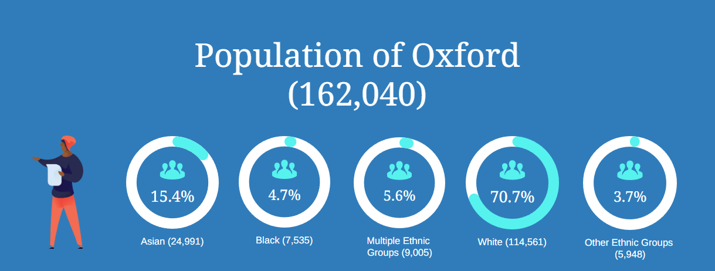

The census also shows an ageing population and the profound health inequality that continues to exist in our city.

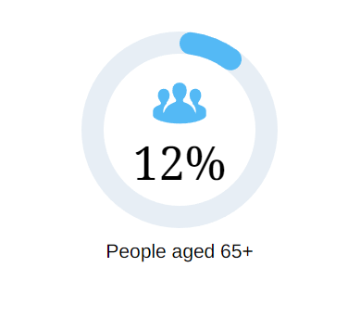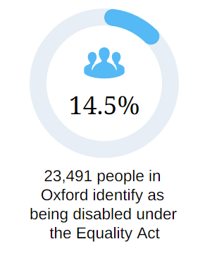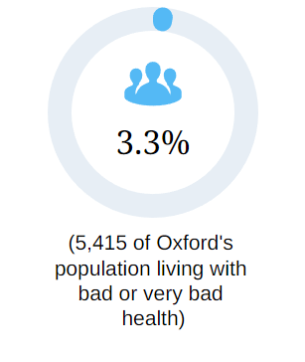
Inequality also exists in significant parts of the city experiencing extreme poverty. The English Indices of Deprivation 2019 results show Oxford has one Lower Layer Super Output Area within the 10% most deprived areas nationally (Northfield Brook) and there are 9 areas in total among the 20% most deprived nationally which are in The Leys, Barton, Littlemore, Rose Hill and Carfax.
Digital disadvantage is also widespread. The Oxford Internet Institute recently conducted a survey of residents to explore the impact of the digital divide in the city. The results revealed that almost a quarter of Oxford residents lack access to the internet, and this lack of access disproportionately affects those from lower-income households and minority ethnic backgrounds.
There are 4,580 registered businesses within the Oxford boundaries that provide approximately 113,900 jobs, each of whom will have a high expectation about how they engage with the city to be successful employers.
Visitors to the city also want a positive experience, and Oxford remains a key destination attracting approximately 7-million-day time and staying visitors per year.

Current Service
The scale of our current front line business activity is significant.
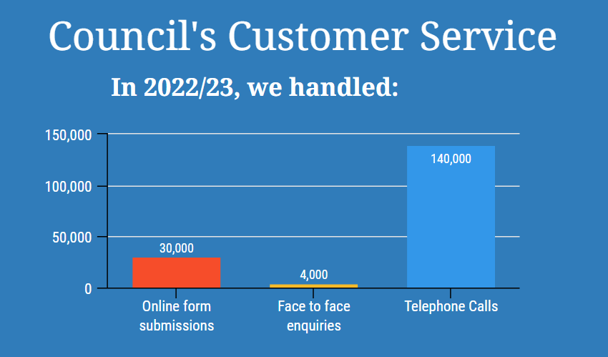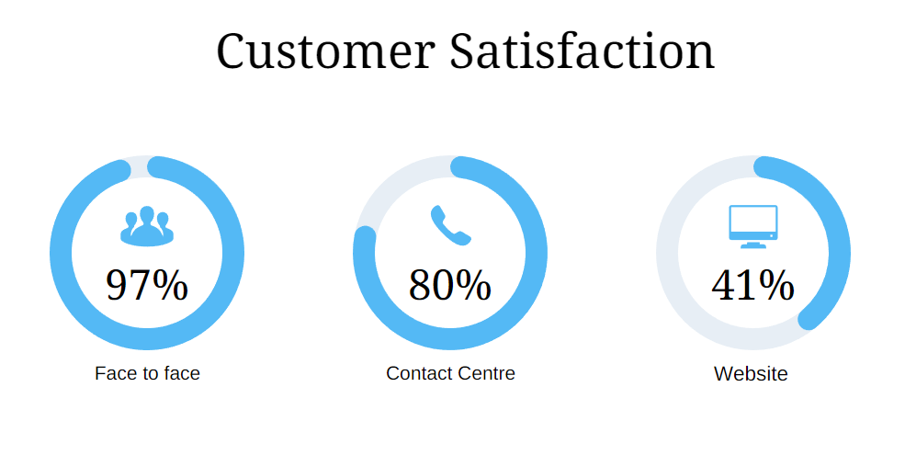
The City Council has been accredited with the Customer Service Excellence quality mark since 2013. This standard recognises organisations that deliver efficient and effective services that place customers at the heart of service provision. The Council’s most recent assessment was in March 2023, where it passed with flying colours with only one partial compliance across the 57 criteria. Additionally, this year the assessors awarded 11 Compliance Plus ratings where the Council were judged to have gone “above and beyond” what was expected.
The Council’s face to face service relocated to the Westgate Library in January 2022, operating for 3 days each week alongside Citizens Advice Oxford. The benefits of this way of working are so much more than co-location. Working together has delivered speedier advice for citizens, joining up access to all Council services (particularly Council Tax, Benefits and Housing). The City Council has been able to signpost more directly to Citizens Advice for specialist debt advice.
The City Council’s Covid response introduced locality hubs to ensure communities received the support and advice they needed during the pandemic. The City Council has built on that approach, creating locality networks in its communities, joining up service delivery across the Council and working with the County Council, other organisations and community groups to ensure it is supporting citizens to get access to the best support and advice.
The development of these locality networks will specifically help to tackle the health and poverty inequalities communities are experiencing. These networks will also help to bridge the digital divide which is a key enabler to improving quality of life.
Understanding the changing demographics as highlighted above, the organisation has access to a comprehensive range of language support services including telephone interpreting, face to face interpreting (Including British Sign Language Interpreters), video calls and document translation services. The current supplier for these is Word360, but we are currently re-tendering for this service, looking for a like-for-like offer which will be in place by the end of August.
Insight shows that Google Translate is widely used by non-English speaking citizens when accessing the internet and so site-specific translation services are not always required.
How we consulted
Citizens have been consulted in a number of ways. These opportunities were used to test objectives and language, and also to understand what barriers are faced in getting access to services. Officers visited existing Community Larders in Rose Hill and Barton and attended a Community Champions Forum at the Museum of Oxford and an online Diversity Forum. In addition, citizens using the contact centre and visiting the front-line service at the Westgate were surveyed on their views.
The Council commissioned a special session for advice providers to understand how the strategy and its objectives would affect their services.
A session was also held with the Director for Customer Experience and Cultural Services at Oxfordshire County Council, to ensure that the partnership approach suggested aligns with their direction of travel.
Individual discussions were held with every Service Head and representatives of their teams, to seek their feedback on the proposed strategy, its objectives and language. This feedback has been used to develop the Citizen Experience action plan and for services to consider their own more specific actions.
Staff were given the opportunity to share their views again on the objectives and language of the strategy, and also on what they would need to help them embrace and deliver against the draft principles of the strategy. This was achieved using a series of online and in person sessions.
Different dimensions of the strategy were further tested with the Policy Officer Group and Equalities Steering Groups, in addition to their feedback on objectives and language. The Policy Officer Group were asked to consider alignment with other existing City Council policies, whilst the Equalities Steering Group has supported the development of the Equalities Impact Assessment.
How we have used our findings
The insights gathered have been used to enrich the action plan, ensuring priorities already underway are still relevant. They have significantly shaped the language used. It has also been a valuable exercise to ensure that all Council services are fully aligned to the strategy principles.
There will be a greater emphasis on supporting those in digital poverty or with lower literacy skills. The action plan includes a review of the Community Involvement Policy, a commitment to explore how the new Resident’s Panel can be better used and how young people can be more formally engaged.
The Council also found a clear opportunity to work closely with its commissioned advice providers to ensure they are able to champion the benefits of digital access and are included in the locality network approach.
Improving the website was unsurprisingly a big priority in the feedback. There was a widespread demand for it to be more user-friendly, with better quality information that is updated regularly. A new approach to the content management of our website is being developed, and citizens will be engaged as part of this process.
The digital divide reported by the Oxford Internet Institute is concerning and persistent. Work has already begun with Activate Learning at the Blackbird Leys Technology Campus. We will be working together using their resources to provide digital skills and employability support for citizens. They will also be helping the City Council to be seen as a viable employer in the community and supporting citizens to apply for roles with us, in particular for the forthcoming apprenticeship scheme.
Better use of data and insight was another key theme. This is reflected in our priority to ensure a co-ordinated approach to the customer feedback and insight we gather from a range of sources including member enquiries, comments and complaints and freedom of information requests. Internally, we also need to ensure that the organisation understands and uses that insight to support decision making and policy formulation.
Through the consultation process, services have also committed to undertake a range of actions to improve their offerings in line with the strategy principles. These include policy reviews, improving web content, reviewing processes and service standards.
In terms of the Citizen Experience Strategy itself there was some debate regarding the use of “citizen” or “customer”. Comments included “customer” having a transactional or consumer meaning but may be a friendlier term. Some feedback said “citizen” may be a word that excludes some of our communities; visitors for example may not feel they are citizens. There was no clear preference overall, or other more suitable suggestions but a strong feeling that whatever word is chosen a definition is included in the strategy. A strap line to the Citizen Experience Strategy has been added to provide further clarity.
A definition has been duly included to say “citizens” are those who live, work in and visit the City Council.
A strap line to the strategy has been added to say, “For everyone that lives in, works in or visits the City of Oxford”.
There was feedback over the vision which used the term “putting you at the heart of everything we do”, which was said to be overused. In addition, the citizen feedback said that what was really important to them was knowing they had been listened to and understanding what the Council had done with any feedback given. The vision has therefore been amended to say, “Put communities and citizens at the heart of how we work, ensuring they actively shape our services and that the right support is available for anyone living, working or visiting Oxford”.
Staff feedback also had clear themes. They were clear they need a better staff directory as well as development in customer service and equalities skills to support citizens and fulfil the ambitions of the strategy. Staff also wanted to set clearer expectations for citizens of the service standards that the Council is working to. This feedback is reflected in the action plan to develop the citizen experience “culture” in the organisation.

Our vision is simple:

Put communities and citizens at the heart of how we work, ensuring they actively shape our services and that the right support is available for anyone living, working or visiting Oxford.

In this strategy, “Citizens” are those who live, work in and visit the City Council. The outcomes and actions in this strategy also cover our relationships with businesses, communities and partners.
We will deliver modern, inclusive and accessible services that embrace the benefits of technology to make the experience quicker and easier for everyone.
Ensuring no-one gets left behind, we will provide a range of ways to contact us with access to specialists for more complex enquiries.
We will make the most of our data and insight, whether that is using citizen feedback to improve our processes, involving citizens in our service design, or utilising our data to spot trends and support business policy and decisions to ensure our services meet the needs of our citizens.
We will strengthen support within communities and work together with partners, agencies and community groups to give holistic, right first time solutions and advice to ensure the early prevention of issues.

We pledge to deliver these simple and ambitious outcomes:
Citizen Focused
- We will put you at the heart of how we work, and develop a learning culture to continually improve our offer to you
- We will listen, use insight and feedback to make sure our services are based on what is needed, and measure success in a way that is accountable to you
- We will use insight to spot trends where we are failing to meet the service standard and improve performance
- We will work collaboratively with our communities, and design services to meet your needs through a variety of contact channels
- We will develop a diverse and engaged workforce that is representative and in tune with our communities

Positive Citizen Experience
- We will make sure the citizen experience as a whole is quicker, easier and better
- We will ensure our staff are supported to give a professional and helpful experience with access to the right tools and technologies
- We will take ownership for delivery and get the basics right
- We will set clear expectations, do what we say we will do and keep you informed of progress

Inclusive Access
- We will deliver modern, accessible services that meet the needs of our diverse communities and promote our equalities objectives. This includes:
  - An easy to use website for information and guidance, accessible through a range of devices including lap tops and smart phones
  - Self-service to access personal information and request services
  - Keeping updated with messages and alerts
  - Interactive social media
- We will deliver face to face and other assisted support, and help the most vulnerable people to ensure their complex needs are met and no one gets left behind
- We will make our services and information clear, concise and accessible to all using language that reinforces our values
- We will do all we can to reduce digital exclusion by improving our citizens skills and access to technology
- To

Get it Right First Time
- We will resolve your needs at the first point of contact where possible
- We will act swiftly to remedy individual service failures and communicate these actions to you
- We will work collaboratively with partners, agencies and community groups to ensure early intervention
- We will ensure our systems and processes reduce unnecessary contact for you, so your needs are resolved at the first time you contact us

Action Plan
The data and insight received during the consultation have helped shaped this strategy and its emerging priorities, and are now embedded in a clear action plan which is laid out below. The delivery of this action plan will be overseen by the Council’s senior management team and progress reported to the relevant Cabinet portfolio holders.

Outcome | Workstream | Start Date | Finish Date
Citizen Focused | Maintaining Customer Service Excellence accreditation |  | Next annual assessment date is November 2023
 | Reviewing our corporate standards, key performance indicators and service offer | June 2023 | November 2023
 | Reviewing the improvement of services from data insight | April 2023 | April 2024
 | Review and refresh of the Community Involvement Policy | September 2023 | December 2023
 | Re-launch and ongoing engagement through the Residents Panel | July 2023 | Continuous
Outcome | Workstream | Start Date | Finish Date
Positive Citizen Experience | Website redesign and content refresh | May 2023 | TBC
 | Development of new online forms | May 2023 | Continuous
 | Implementation of the revenues and benefits new online forms automation | April 2023 | October 2023
 | Communications Plan to support and encourage digital access | June 2023 | October 2023
 | Service based process improvement programme | May 2022 | May 2023
Outcome | Workstream | Start Date | Finish Date
Inclusive Access | Development of face to face assisted support model for vulnerable and more complex queries | Continuous
 | Development of collaborative approaches with community groups, partner and agencies offering (Thriving Community Strategy) | Continuous
 | Supporting our communities to have access to digital technology ​ and better digital skills | May 2023 | Continuous
Outcome | Workstream | Start Date | Finish Date
Get it Right First Time | Service integration optimised across organisation | Continuous
 | Developing and aligning commissioned advice offer | May 2023 | May 2024
 | Behavioural insight | January 2023 | March 2024
 | Developing citizen experience culture for staff including digital and technology skills | April 2023 | March 2024

Success Measures
The Council will be improving digital access to services for citizens and improving back-office automation that will mean less manual intervention by staff. The Council will be measuring the extent and success of how citizens use these new digital processes. It will also continue to measure customer satisfaction with its web, contact centre and face to face services. These will include stretching targets that sit alongside clear plans for improvement.

